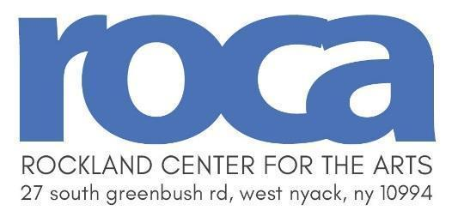
Announcing Scholarship Applications for Children and Teens
Fall Art Classes @ RoCA
Fall term begins September 14, 2026
Children’s Scholarships are made possible thanks to the the Zaklin Family Foundation, the Louis Spitz Scholarship Fund, the Barbara Kalvert Scholarship Fund, the Zara Crowley Foundation, Sarah & Stephen Thomas, and the Mark & Jessie Milano Foundation.
APPLICATION DEADLINE: September 4, 2026
August 2026
Dear Parent,
Do you have a creative child who would benefit from art instruction and inspiration? If your child enjoys art, but you cannot financially support a class, please read this letter. Please fill out the enclosed application and registration forms completely to be considered for a fall class scholarship at Rockland Center for the Arts.
Rockland Center for the Arts (RoCA) is a non-profit art school in West Nyack that offers art classes for ages 4 to adult. Each semester we award a limited number of full scholarships to our art classes. Scholarships will be awarded on the basis of financial need.
A complete listing of classes can be found on our website at www.rocklandartcenter.org. Please make sure to fill out the registration and scholarship form completely. Due to the high volume of applications, only complete applications with registration will be processed. No applications will be accepted after the September 4th deadline, and we can only accept one application per family each semester. Students should list three class preferences in the event their first choice isn’t available.
All applicants will be emailed and informed of the status of their application. If you have any questions, please call me at (845) 358-0877.
Sincerely,
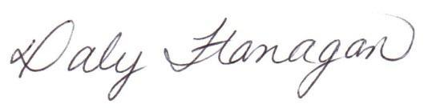
Daly Flanagan
Executive Director

Scholarship Application for Children & Teens: Fall Art Classes
Fall Term begins September 14, 2026 Application Deadline: September 4, 2026
Name of Applicant Birth date Male or Female (circle one)
Address _____________________________________________________________________________ street city state zip
Daytime Phone: Evening Phone:________________________________
Email___________________________________________________________________________________

A. Name of Parent/Guardian: _____
B. Occupation(s) of Parent(s)/Guardian(s):__________________________________________________
C. Number of Children in Family: School of Child:_____________________________

Have you ever received a scholarship from Rockland Center for the Arts? Yes No
If yes: When? (Yr & Semester) _____ Type: School Summer Day Camp Both
Scholarships are based on financial need. Please describe your circumstances at this time to indicate eligibility:
_____________________________________________________________________________________
_____________________________________________________________________________________
_____________________________________________________________________________________
_____________________________________________________________________________________
If you were referred for a scholarship, please indicate below:
Person who referred you: Phone:_________________
School or Agency which referred you:_____________________________________________________
References: List two people who know you personally - not relatives:
Name Phone: ________________________________
Name Phone:________________________________

List the courses you are interested in below:
(Please list three choices. Write the course number & title. Refer to www.rocklandartcenter.org for class info)
1.___________________________________
2.___________________________________
3.___________________________________
Note:
- Applications will not be accepted after the deadline.
- Only complete applications (that include a filled in registration form) are considered.
- Scholarships are granted on a space available basis.
- Rockland Center for the Arts follows a non-discriminatory policy on admissions and employment.
- Scholarship awards are not redeemable for cash and are non-transferable.

Does your child have any special assistance considerations? Please indicate if you would like to discuss details with the Executive Director.

Please mail the completed application and send to:
Daly Flanagan, Executive Director Rockland Center for the Arts 27 South Greenbush Road West Nyack, NY 10994
dflanaganrca@aol.com

Fall 2026 Scholarship Registration Form
Course  Number | Course  Title |  |  |  | Tuition | Model  Fee | Materials  Fee | Total
Registration Information
Student Name:
Address:
City: |  |  |  | State: |  | Zip:
Home Phone: |  |  |  | Cell / Work Phone:
E-mail Address:
Parent/Guardian Name: |  |  |  |  | Child Birth Date |  | Mon | Yr

Please mail the completed application and send to:
Daly Flanagan, Executive Director Rockland Center for the Arts 27 South Greenbush Road West Nyack, NY 10994
dflanaganrca@aol.com

