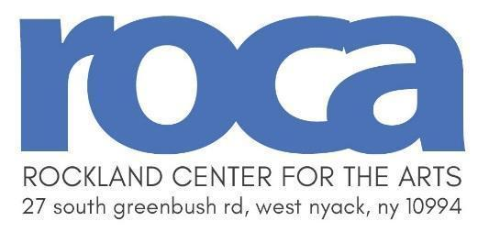
Scholarship Application for Adults
Fall 2026 Art Classes
Ceramic Scholarships are made possible thanks to the Louis Spitz Scholarship Fund.
Fall Term Begins September 14, 2026
Application Deadline: September 4, 2026
Name of Applicant __________________________________________________
Address______________________________________________________________________________ street city state zip
Daytime Phone: Evening Phone:________________________________
Email________________________________________________________________________________

Have you ever received a scholarship from Rockland Center for the Arts? Yes No
If yes: When? (Yr & Semester) _____
Scholarships are based on financial need. Please describe your circumstances at this time to indicate eligibility:
____________________________________________________________________________________
_____________________________________________________________________________________
If you were referred for a scholarship, please indicate below:
Person who referred you: Phone:_________________
References: List two people who know you personally - not relatives:
Name Phone: ________________________________
Name Phone:________________________________

List the courses you are interested in below:
(Please list three choices. Write the course number & title. Refer to the catalog or www.rocklandartcenter.org for class info)
1.___________________________________
2.___________________________________
3.___________________________________
Note:
- Applications will not be accepted after the deadline.
- The scholarship award does not cover material or model fees.
- Only complete applications are considered.
- Scholarships are granted on a space available basis.
- Rockland Center for the Arts follows a non-discriminatory policy on admissions and employment.
- Scholarship awards are not redeemable for cash and are non-transferable.
Please mail the completed application and send to:
Daly Flanagan, Executive Director Rockland Center for the Arts 27 South Greenbush Road West Nyack, NY 10994
Email: dflanaganrca@aol.com

Fall 2026 Scholarship Registration Form
Course  Number | Course  Title |  |  |  | Tuition | Model  Fee | Materials  Fee | Total
Registration Information
Student Name:
Address:
City: |  |  |  | State: |  | Zip:
Home Phone: |  |  |  | Cell / Work Phone:
E-mail Address:

Please mail the completed application and send to:
Daly Flanagan, Executive Director Rockland Center for the Arts 27 South Greenbush Road West Nyack, NY 10994

